The python file is running on a python version 3.7.9

* The process can be demonstrated by the video as uploaded;
* The following files are required to run the *silo-torus* model;

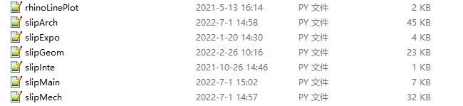

1. A python program starts with the main function: slipMain.py.

2. rhinoLinePlot.py is the function to plot contour lines in Rhino.

3. The rest py files are subfunctions:

3.1 slipGeom.py file is used to generate the slip contour of the tunnel face;

3.2 slipMech.py file is executable to generate force/stress for the tunnel face;

3.3 slipArch.py file is executable to generate silo load;

3.4 slipInte.py file is used to estimate shear strength reduction at interface;

3.5 slipExpo.py file is used to export data saved in csv files;